**CS604P Assignment #1 spring 2023**

Name: Abdul Rehman.

VU-ID: BC220424444.

**Solution:**

**Reader File Code Screenshot:**

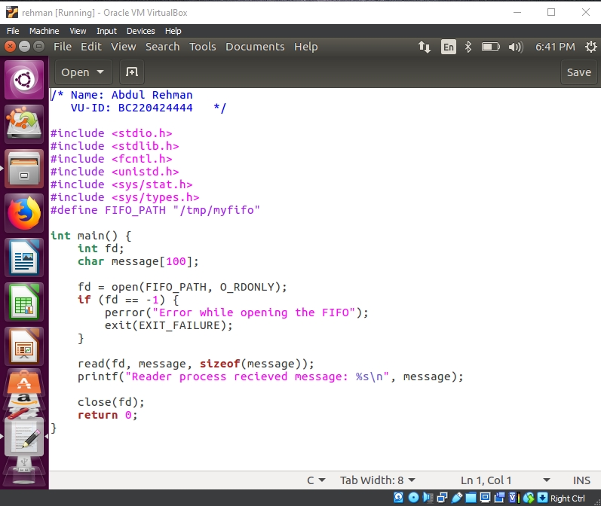

**Writer File Code Screenshot:**

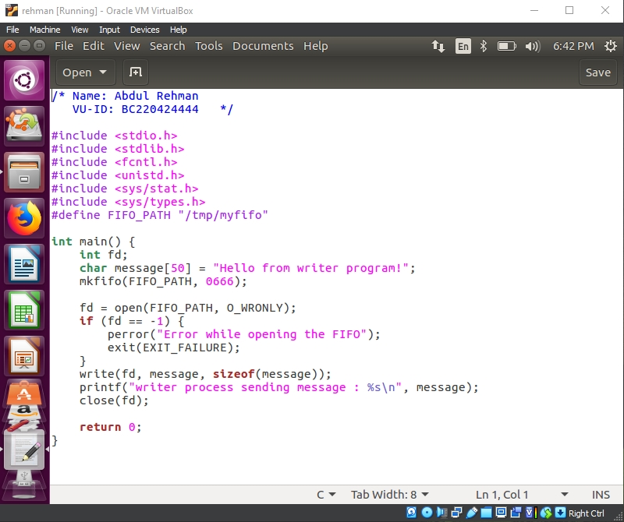

**Terminal Output Screenshot:**

